Jerry Hanock T

210519104040

# Assignment 3:

Write python code for blinking LED and Traffic lights for Raspberry pi.

Only python code is enough, no need to execute in raspberry pi.

Note: you are allowed to use web search and complete the assignment.

## Program :

gpiozero import Button, TrafficLights, Buzzer

mport RPi.GPIO as GPIO

import time

from time import sleep

buzzer = Buzzer(15)

button = Button(21)

lights = TrafficLights(25, 8, 7)

while True:

button.wait_for_press()

buzzer.on()

light.green.on()

sleep(1)

lights.amber.on()

sleep(1)

lights.red.on()

sleep(1)

lights.off()

buzzer.off()

GPIO.setmode(GPIO.BCM)

GPIO.setup(LED_PIN, GPIO.OUT)

while True:

GPIO.output(LED_PIN, GPIO.HIGH)

time.sleep(1)from

GPIO.output(LED_PIN, GPIO.LOW)

time.sleep(1)

GPIO.cleanup()

##### Screenshot 1 :

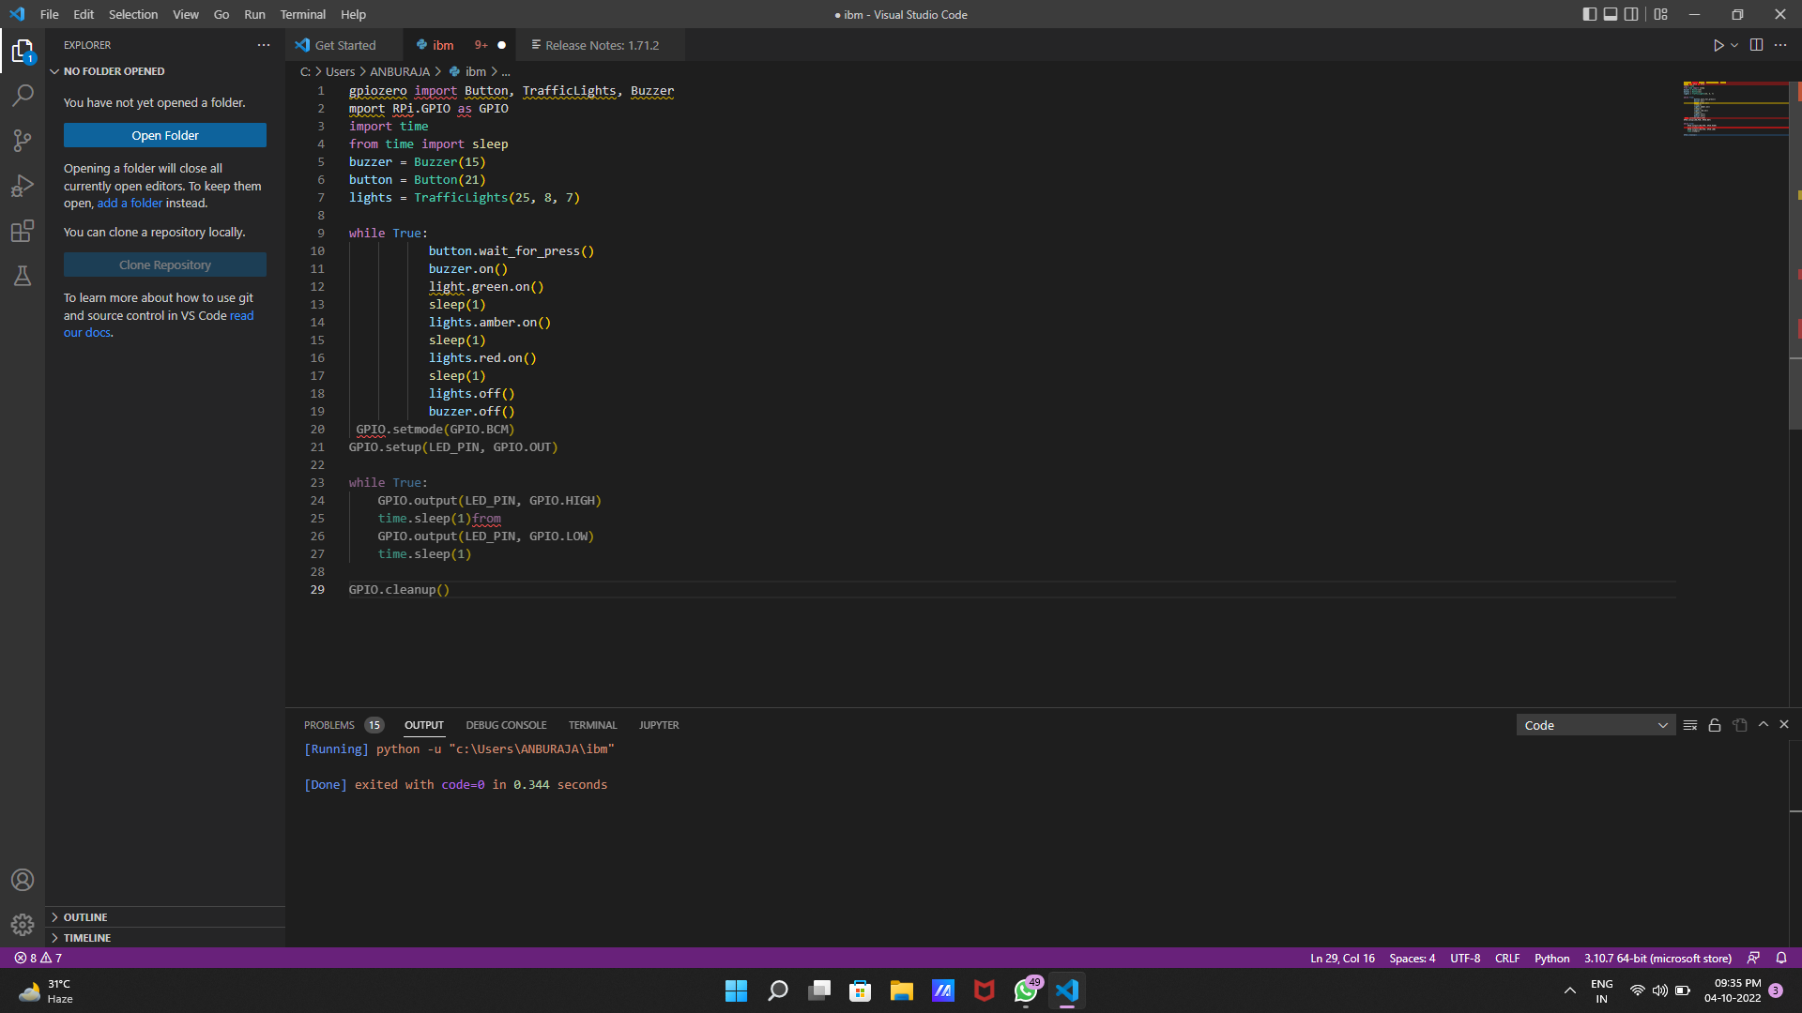

### Sreenshot 2 :

Program :

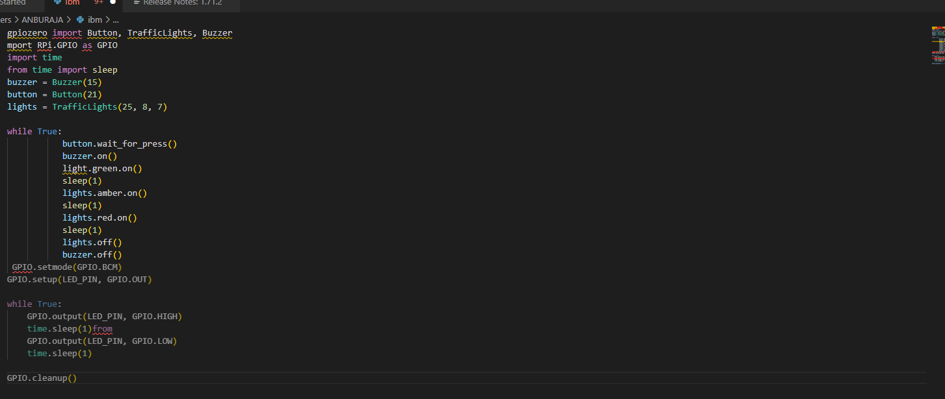

#### Screenshot 3 :

Output :

